TACACS+ and Radius on Microsoft Azure and Amazon AWS

Cisco CCNP Lab 6

Mason and Hoffman – Period 6-8

Jeffrey Zhang

Purpose

The purpose of this lab is to configure remote authentication protocols such as TACACS+ and Windows Radius to log into cisco network management devices on Microsoft Azure Server farms and Amazon AWS Server farms.

Background

Local authentication that is performed on routers and switches tend to have security that isn’t optimal, as such, could be bypassed easily by exploiting maintenance modes during boot. Remote authentication methods such as TACACS+ and Windows Radius will prevent the user from bypassing the authentication during boot. Furthermore, doing these protocols in a secure location with secure providers would

Lab Summary

In this lab, my lab partner (Jimmy) and I configured TACACS+ and Windows Radius. We made 2 virtual machines that connected to real life Cisco 2901 routers; one for configuring TACACS+ and one for configuring Windows Radius.

I configured the virtual machine with Windows Radius using Windows Server 2016.

The process begins with initiating the various network policies required for configuring the routers.

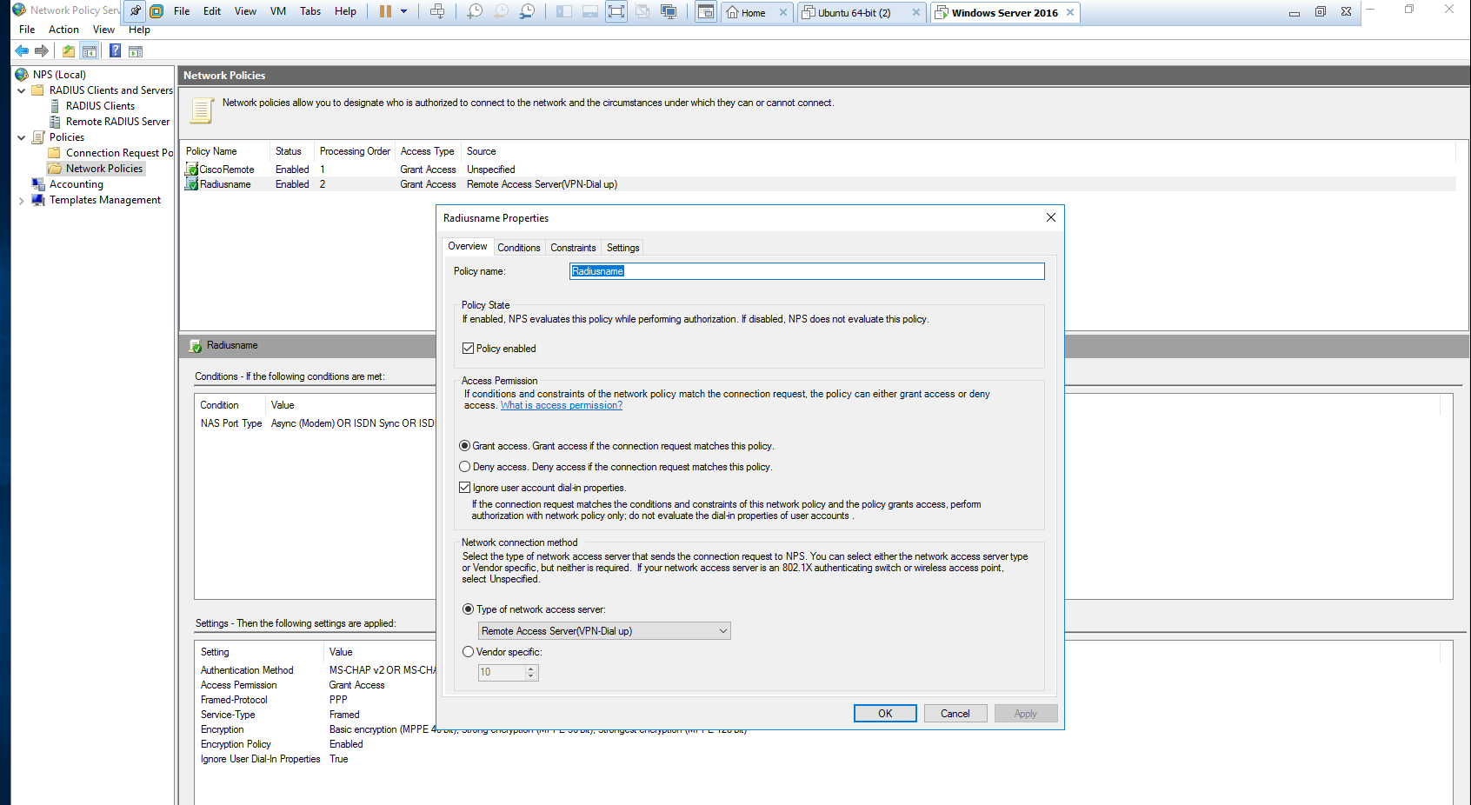

Configuring the groups

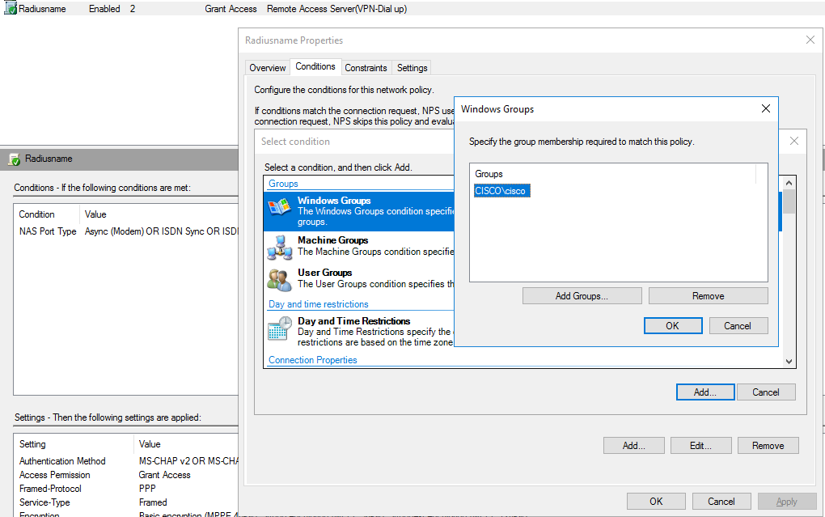

Adding the Windows Radius router

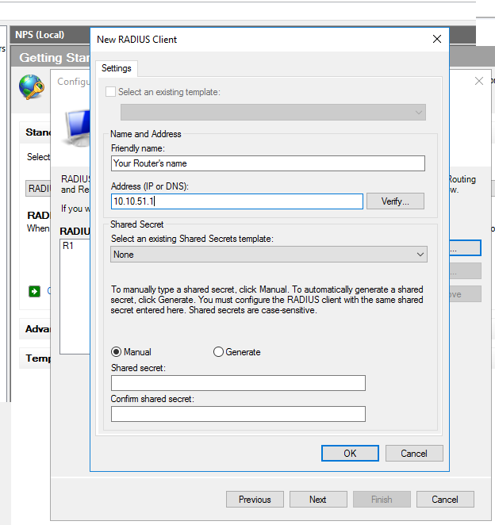

Configuring the IP address of the server itself.

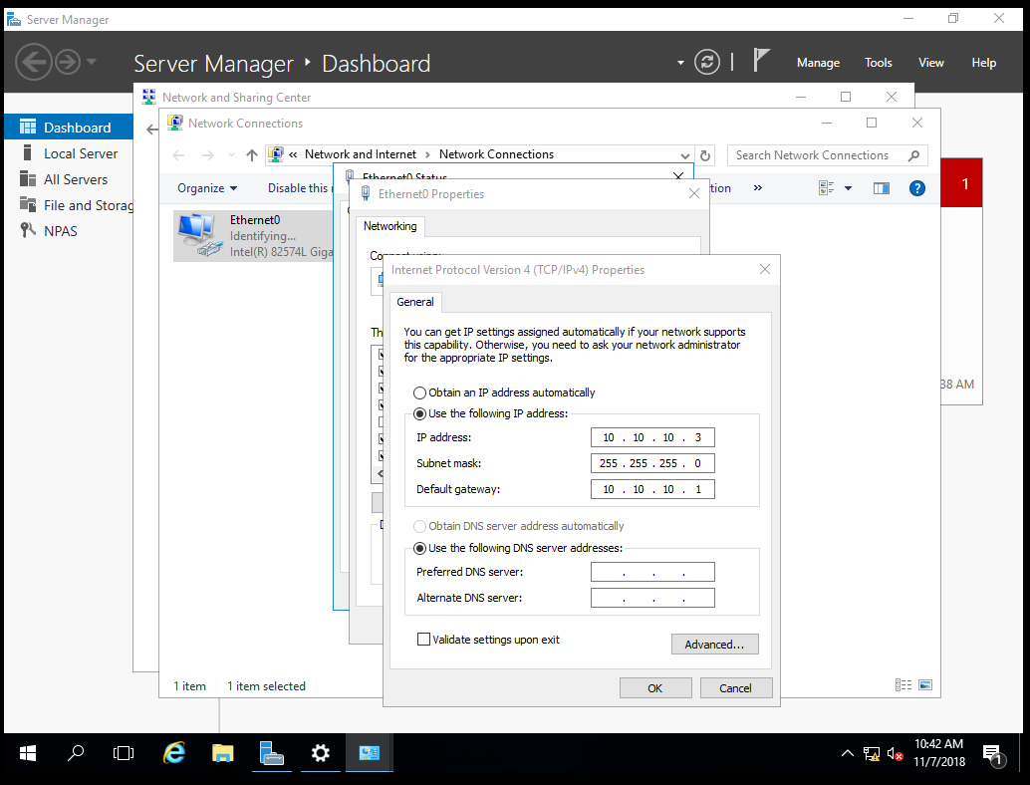

After setting up the Radius client on the server, we entered active directory services, in which we added our user group, domain, and user to log into our router.

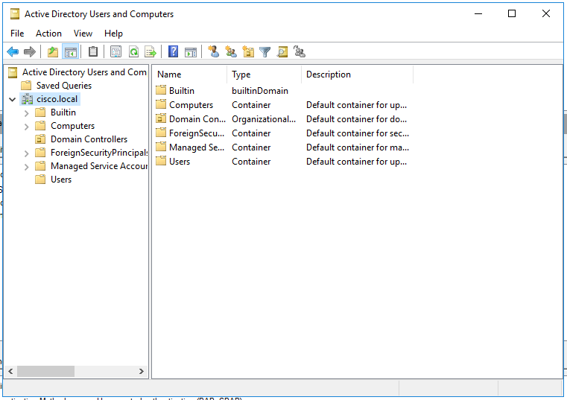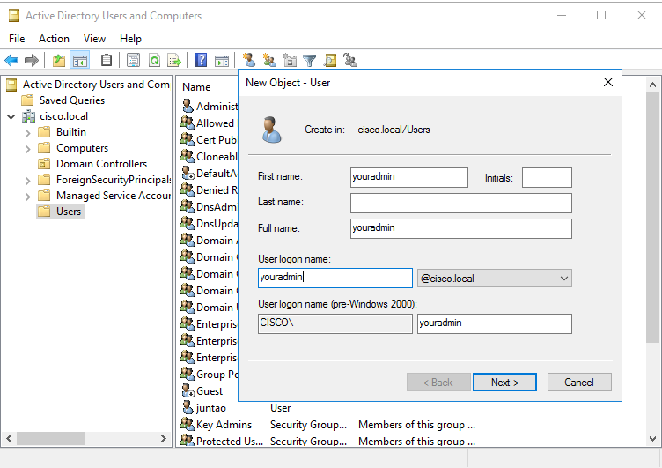

My partner Jimmy used a Linux Ubuntu Virtual Machine to configure TACACS+. He entered the terminal executed the “sudo –i” and then “apt-get update” so that he could install other services through the terminal.

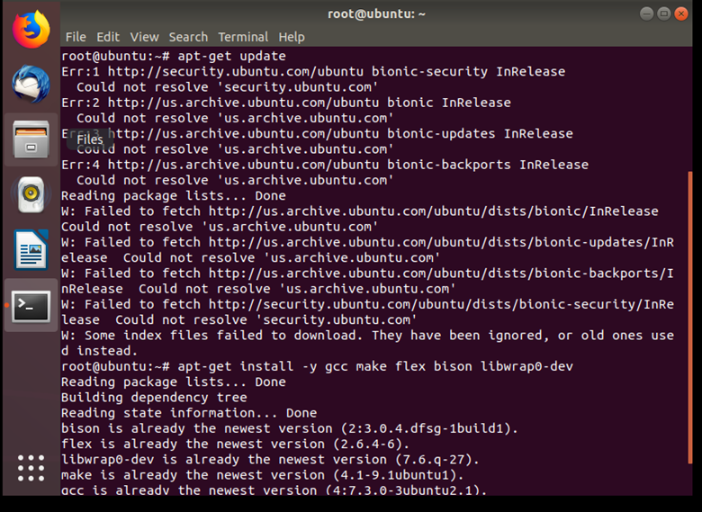

After downloading TACACS+ services, he edited the configuration file section with “nano …” to setup TACACS+ remote authentication protocol.



Inside the configuration file, I defined the key (domain) between my server and router, the group with privilege levels and users in such groups.

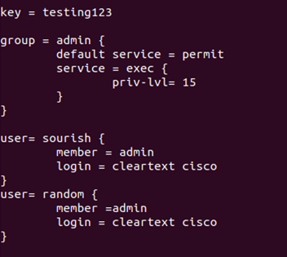

The last step was to check port 49 with the command “lsof -i :49” to see whether TACACS+ protocol is running. To finalize the setup of TACACS+ protocol, the command must be case sensitive in order for it to work.

Configurations

Below are the router configurations for the Windows Radius router.

hostname R1

boot-start-marker

boot-end-marker

enable password cisco

aaa new-model

aaa authentication login default group radius local

aaa authorization exec default group radius if-authenticated

Username backup password cisco

aaa session-id common

memory-size iomem 10

ip cef

no ip domain lookup

no ipv6 cef

multilink bundle-name authenticated

voice-card 0

license udi pid CISCO2901/K9 sn FTX1704Y038

license accept end user agreement

license boot module c2900 technology-package securityk9

license boot module c2900 technology-package uck9

vtp domain cisco

vtp mode transparent

redundancy

interface Embedded-Service-Engine0/0

no ip address

shutdown

interface GigabitEthernet0/0

ip address 10.10.10.1 255.255.255.0

duplex auto

speed auto

interface GigabitEthernet0/1

no ip address

shutdown

duplex auto

speed auto

interface Serial0/0/0

no ip address

shutdown

clock rate 2000000

interface Serial0/0/1

no ip address

shutdown

clock rate 2000000

ip forward-protocol nd

no ip httbackp server

no ip http secure-server

radius-server host 10.10.10.3 key 123456

control-plane

mgcp profile default

gatekeeper

shutdown

line con 0

password 123456

line aux 0

line 2

no activation-character

no exec

transport preferred none

transport output pad telnet rlogin lapb-ta mop udptn v120 ssh

stopbits 1

line vty 0 4

transport input all

scheduler allocate 20000 1000

end

TACACS+ Router configurations:

hostname R1

aaa new-model

aaa authentication login default group tacacs+ local

aaa authentication enable default group tacacs+ enable

aaa authorization config-commands

aaa authorization commands 0 default group tacacs+ none

aaa authorization commands 15 default group tacacs+ none

aaa accounting send stop-record authentication failure

aaa accounting update newinfo periodic 5

aaa accounting exec default start-stop group tacacs+

aaa accounting network default start-stop group tacacs+

aaa session-id common

ip domain name cisco.com

no ipv6 cef

vtp domain cisco

vtp mode transparent

username backup password 0 cisco

interface GigabitEthernet0/0

ip address 10.10.10.1 255.255.255.0

duplex auto

speed auto

no shutdown

ip tacacs source-interface GigabitEthernet0/0

tacacs-server host 10.10.10.3

tacacs-server directed-request

tacacs-server key testing123

end

Problems

Since we never dealt with Windows server 2016 before, we had to solely rely on the internet to go through the lab. The main issue was, most of the guides that we found were out of date, and didn’t match our current version of Windows server. So we had to take reliable patches of certain credible articles to piece together the process of executing Windows Radius successfully on Windows Server 2016. The router configurations were mostly up to date however. While Jimmy configured TACACS+, he ran into the same issue where a lot of the guides setting up TACACS+ were out of date, or weren’t relevant to our current situation.

Conclusion

This lab aims to teach us how to configure remote authentications over the less secure local authentications on cisco devices. This also serves as my first lab configuring Windows Radius on a virtual machine, connected to a physical cisco router.